In a group of 4, choose a setting for your pilgrimage (time and place), and decide where your group will make its pilgrimage, for what purpose (what is your end goal) and what is your method of transportation. Please keep in mind, you must reach your destination (you can be a little creative here but don’t go too crazy now.) This section must be minimum of 20 lines.

The Mickey Mouse Introduction

- Four characters, from all around
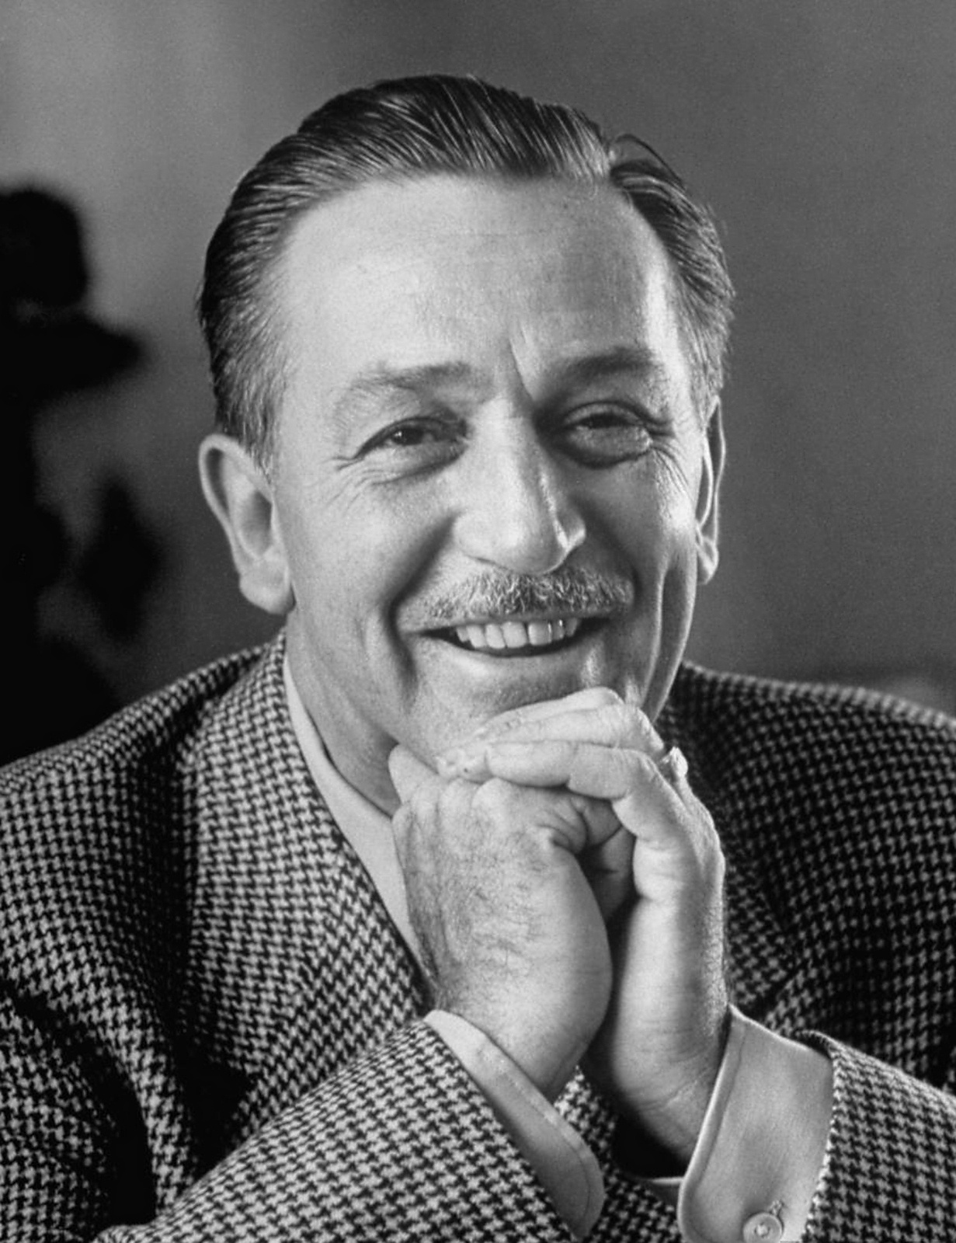
- Come back home from out of town
- We start off the tale of little miss Minnie
- Everyone knows she’s the queen of Disney
- With a black skirt and her polka dots
- For Mickey Mouse she has the hots
- Next is her friend, Donald the Duck
- His pantless attire leaves us dumbstruck
- His temper spews like a raging smokestack
- He’s increasingly savage with every quack
- We now introduce Sleepy, our dearest friend
- On this little Dwarf Snow White could depend
- He sings and dances and is full of joy
- He’s known as the Princess’ Golden Boy
- Speaking of golden, here is Prince Charming
- He’s just so dashing, it’s almost alarming
- His legendary tales none can outshine
- The face of chivalry he redefined
- These last two weeks have been a lovely vacation
- But for our journey to Disney World, let’s start the narration
- Each of you will tell your story
- Be full of life and don’t be boring
- The one with the best tale of make believe
- Will be the star of Disney’s parade on New Year’s Eve

***Personal Character Prologue: Each character/student will write a 15-20 line (prologue) description of his or her character in the FIRST person, including various traits, as well as the reasons for making the pilgrimage (Have questions, refer to Pardoner’s prologue). You will be referring back to the destination throughout each character’s prologue.

The Mouse

- A common saying goes “ladies first”
- So here I go (is Minnie Mouse) with my (her) opening verse
- My name is Minnie Mouse and I’m here to share
- A story to to make this journey easy to bear
- A tale so entertaining, none will disagree
- My place in the ‘Year’s Eve’s Parade, this will guarantee
- Now my life is pretty perfect, I cannot complain
- Nothing about it fills me with disdain
- With love and comfort and happiness I live
- To stay this way forever, anything I would give
- But all about me this story is not
- Instead, someone else (and they’re in earshot) *pause and nod head towards Sleepy?*
- For this tale is one of lies, struggle, and sorrow
- And from one of their secrets, this story I will borrow
- You’ll hear the tale of a little man
- Who consumes more than he can.
- His life is messed up and filled with neglect
- Unlike my life which is so perfect!
- Now open your ears wide, listen very closely
- And I’ll do my best not to tell it verbosely

Personal Character Tale: Each character will write a 30-40 line story in third person, again in Chaucer’s writing style, to be told to the group. (Have questions, refer to Pardoner’s Tale). Here they used another character in the tale- that is optional- but it makes the stories a tad more interesting

The Mouse Story:
- You all seem boringly normal and alright
- Awake during the day and sound asleep at night
- But Sleepy the dwarf wasn’t this way
- When the sun was bright, he would sleep all day
- It started when he was of just a small size
- When his mother never opened his eyes
- Soon, Sleepy had to go to school and learn in class
- But despite all attempts, he could not pass
- Sleepy would hide in the closet that held brooms
- And slept until he was found by the cleaning crew
- With all the disturbances of the boys and girls,
- he found it hard to escape to his dream world
- Angry, frustrated, sad and yearning for dreams
- Sleepy found himself at a nearby Walgreens
- While wandering around, he saw a bottle colored bright blue
- Labeled “Nyquil” and he knew what to do
- One sip was all he needed for him to drift away
- Into a slumber that could last for days
- One sip turned into a bottle a day
- Until Sleepy was addicted to Nyquil all the way
- He drank and drank until he could not stop
- The addiction was getting worse with every drop
- With this drug, he lost his friends and family
- On top of that, he lost his sanity
- There was a time when he stooped even lower
- When he tried to steal from a saintly church goer
- That failed attempt didn’t get him anywhere
- So he got involved in another affair.
- Sleepy tried to sell his own mom
- Just for a bottle that fit in his palm
- One day, while wandering in the woods
- He caught a whiff of some freshly baked goods
- The scent drew him to a nearby cottage
- Inside he found a full breakfast complete with sausage
- There he met the beautiful Snow White
- And he told her about his awful plight
- She took him in under her wing
- She cured his addiction and taught him to sing
- He met six others just like his own
- They formed a brotherhood stronger than stone
- Sleepy’s life went from dark to light
- He turned his wrongs into rights
- Sleepy’s tale shows us all
- It’s possible to rise after the fall

Here is where you would add more of the Entire Prologue that you wrote as a group

Personal Character Prologue: Each character/student will write a 15-20 line (prologue) description of his or her character in the FIRST person, including various traits, as well as the reasons for making the pilgrimage (Have questions, refer to Pardoner’s prologue). You will be referring back to the destination throughout each character’s prologue.

The Prince:
- That’s a nice story Minnie, I’ll give you that
- But once they hear mine your’s will fall flat
- I am Prince Charming! But this you have known
- Now prepare yourself to have your mind blown
- Everyone I know says that true love is forever
- But I think that none should commit to this endeavor
- True love is a bore, it’s terribly dull
- When someone says otherwise, I tell them that’s bull
- I live in royalty and can do as I please
- Staying with just one woman is like a disease
- Yeah, I’m a player, I’ll be the first to admit
- But sadly not everyone can handle my wit
- Plagued by fidelity, it’s just a shame
- Those who stay married have lost all their game
- Now I can’t say that I’ve been this gorgeous forever
- I’ll admit when I was young I was quite bland, however
- Soon I grew out of my pimple faced days
- I started eating healthy and exercised on all but Wednesdays
- And now I am beautiful, you know that it’s true
- Everywhere I go women stick to me like glue
- Now onto my story, of a friend who’s in love
- Some may know him for his ears and white glove
- No, not Michael J, it’s just a regular old mouse
- And this is the story of him and his spouse
- Of why their love is a total mistake
- Just the thought of it gives me a headache

***Personal Character Tale: Each character will write a 30-40 line story in third person, again in Chaucer’s writing style, to be told to the group. (Have questions, refer to Pardoner’s Tale)

The Prince Story:
- Once upon a time, at the University of Disney
- There was a young mouse whose name was Mickey
- He was definitely popular, and in so much demand
- All the ladies wanted to be in his hands
- But he never could keep to just one gal
- And he was always a wingman to his very best pal
- Mickey took to the hills at the sound of “relationship”
- He wasn’t looking for that kind of partnership
- By the time they were seniors, they had played the field
- Broken every girl’s heart, and they never healed
- But alas, one fateful day, all of this changed
- Because our friend Mickey had his heart rearranged
- He went to the market to buy some cheese
- But there was only one block left for him to seize
- As he grabbed for it with his big white glove
- Another set of fingers approached from above
- He looked up and saw the most beautiful girl
- Just looking at her made his heart whirl
- He had not seen her before, she didn’t go to his school
- But he thought she was more perfect than an emerald jewel
- Without saying a word, he left the market behind
- But he just wished that this moment he could rewind
- So he turned around and said “Hey, what’s up?”
- She gave him a smile prettier than a buttercup
- They exchanged numbers and planned for a date
- Little did he know this would seal his fate
- Their relationship grew day by day
- And the female mouse brought him out of his player ways
- When once he would jump from girl to girl
- Now Mickey’s found the girl of his world
- Right now this tale sounds happy and sweet
- But Mickey lost something when he was whisked off his feet
- He thought he had found true love at last
- But instead he was sulking at a couple’s dance class
- Now he was glad for Minnie, he was happy at last
- But he still longed for his good old life from the past
- From a soaring eagle to a caged bird he went
- That was the winter of his discontent
- And when not freedom he chose but marriage instead
- He sealed his fate as the two of them were wed
- This is the tale of a mouse who lost his manhood
- When he married that girl, he gave up all that is good

Here is where you would add more of the Entire Prologue that you wrote as a group

. Personal Character Prologue: Each character/student will write a 15-20 line (prologue) description of his or her character in the FIRST person, including various traits, as well as the reasons for making the pilgrimage (Have questions, refer to Pardoner’s prologue). You will be referring back to the destination throughout each character’s prologue.
The Duck:
- Life is such a funny thing
- always taking, never giving
- My name is Donald and I’m a duck
- When it comes to life, I don’t give a f***
- Stop! There’s no need to act like a fool
- Don’t you know we are in a school!
- You’re right, you’re right. It’s time I tell my tale
- I will win the competition without fail
- Now to introduce a character so vain
- Just being in his presence is a pain
- He experiences a journey of extreme transformation
- For which there is no reasonable explanation
- Why can’t something like this happen to me?
- I am fAAAR more noble than he
- All day, he hears ladies’ chant
- And here I am without any pants
- He went from not to hot overnight
- Now I tell this tale purely out of spite

. Personal Character Tale: Each character will write a 30-40 line story in third person, again in Chaucer’s writing style, to be told to the group. (Have questions, refer to Pardoner’s Tale)

The Duck Story:
- Once upon a time eight ducklings were born
- It was a very bright and happy morn
- The first seven were fluffy and cute
- But the eighth looked like a mangy brute
- He was beaten, teased, and verbally abused
- He often returned home bloody and bruised
- This is how it was for his first few years
- He was always bullied by his peers
- While the other ducklings grew to be strong
- He never felt like he belonged
- No girls wanted to be with him
- His situation was very grim
- Until he reached his adolescent years
- And his life began to change gears
- His voice lowered and his ugliness faded
- His looks improved, oh yes they did
- Once he was a poor young lad
- Now he’s the baddest of the bad
- He was not run of the mill
- He had looks that could kill
- And just like that the ugly duckling became
- A beautiful swan with fortune and fame
- But alas folks, the story does not end there
- This is where the tale hits a snare
- Now he bounces from chick to chick
- But none of them ever seem to stick
- After all they were never good enough for him
- To him they were never proper and prim
- Once he was humble, and he was modest
- Now he’s a player and never very honest
- This swan that we all adore
- His days of glory are done for
- Because his looks went to his head
- He couldn’t see what was coming ahead
- A future where he was bullied once more
- Because of his vanity that the ladies abhor
- No one wanted to be around the pretentious priss
- He was someone that no lady would miss
- This is the way that the hated swan lives
- A life that takes and never gives

Here is where you would add more of the Entire Prologue that you wrote as a group
. Personal Character Prologue: Each character/student will write a 15-20 line (prologue) description of his or her character in the FIRST person, including various traits, as well as the reasons for making the pilgrimage (Have questions, refer to Pardoner’s prologue). You will be referring back to the destination throughout each character’s prologue.
The Dwarf:
- Nice try Donald but that story severely lacked
- It seems like a tale that had no impact
- My name is Dopey the Dwarf, but you already knew that
- How about before my story we have some chitchat?
- I hail from below, in the mines I make my living
- Sharing a house with Snow White, who’s just so caregiving*
- With six other dwarfs it’s a very crowded house
- There’s barely any room for even a mouse (look at Minnie)
- We dig up gems to sell for a profit
- When we come up with nothing, it’s so catastrophic!
- But most of the time things go pretty well
- We make lots of money, after the gems we sell
- And with that we afford everything we need
- Including clothing, which is something good indeed
- But I know some who doesn’t wear pants
- Walking around with legs that are covered in ants
- They seem not to care, I don’t understand why
- I think with society they should comply
- Now everyone gather as I will now start
- On this amazing tale that will soon tear all others apart

Personal Character Tale: Each character will write a 30-40 line story in third person, again in Chaucer’s writing style, to be told to the group. (Have questions, refer to Pardoner’s Tale)

The Dwarf Story:

- There once was a bear whose pelt was yellow
- He was after all a rather swell fellow
- He is widely known as Winnie the Pooh
- But this tale is known to only a few
- Fond of honey and sweets alike
- Without it he’d go on a hunger strike
- None looked as good a Winnie the Pooh
- With his bright red shirt and pants of blue
- One day he noticed his honey supply was low
- On a journey he decided to go
- He’d heard a rumor of a beehive far away
- If he started now he could be there in a day
- And get him some honey that could last him a while
- Just the thought of that made him smile
- He packed his bags and was on his way
- Across the valley and into the fray
- He went three miles north and three miles west
- Savoring every moment of his wonderful quest
- Around midday he was stopped by his friend
- Piglet the pig who hailed from around the bend
- He warned that the bees were full of greed
- For a pound of honey they’d make his wallet bleed
- Winnie laughed off the warning and went on his way
- Full of confidence and willing to pay
- Later that evening he came upon the coveted hive
- At the sight of the honey he felt so alive
- As he approached he was quickly seized
- By an army of angry worker bees
- The bees took him to their beloved queen
- Whose looks were cold and frightfully mean
- The price she asked for her glorious honey
- Was far greater than his total amount of money
- But Winnie was clever, he knew what to do
- He came up with an idea, it was a breakthrough
- He noticed the bee’s hive was bare
- They had plenty of honey, but no clothes to wear
- So he offered his pants as compensation
- The queen was confused by this affirmation
- She didn’t understand a bee’s use for pants
- Until she noticed the hive’s thunderous chants
- She finally agreed with the bear’s request
- Winnie complied and began to undress
- He left the bees content with their new clothes
- With a jar full of honey, on his way home he goes
- So Winnie went home and did a happy dance
- This has been the story of how he lost his pants

Here is where you would then insert the last lines of your entire prologue to finish the tale, reach your destination and emphasize the moral(s) of the characters.

The Mickey Mouse Introduction

Four characters, from all around
Come back home from out of town
We start off the tale of little miss Minnie
Everyone knows she’s the queen of Disney
With a black skirt and her polka dots
For Mickey Mouse she has the hots
Next is her friend, Donald the Duck
His pantless attire leaves us dumbstruck
His temper spews like a raging smokestack
He’s increasingly savage with every quack
We now introduce Sleepy, our dearest friend
On this little Dwarf Snow White could depend
He sings and dances and is full of joy
He’s known as the Princess’ Golden Boy
Speaking of golden, here is Prince Charming
He’s just so dashing, it’s almost alarming
His legendary tales none can outshine
The face of chivalry he redefined
These last two weeks have been a lovely vacation
But for our journey to Disney World, let’s start the narration
Each of you will tell your story
Be full of life and don’t be boring
The one with the best tale of make believe
Will be the star of Disney’s parade on New Year’s Eve

