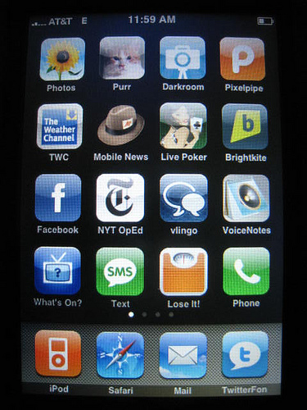
1984 Symbolization Activity
Big Brother App Store!
Welcome to the Big Brother App Store! Today, you will need to create a variety of Apps that symbolically represent various aspects of the plot in 1984. Follow these steps to create your visual product.
- Decide Point of View- your apps need to reflect one consistent point of view. You may choose apps that support Big Brother, Goldstein and The Brotherhood, or the Citizens of Oceania (loyal or not). Each app needs to be reflective of that standpoint as it is represented in the story.
- Fold your paper in quarters. You will need to create two apps …one in each quarter.
- The apps need to be colorful. They must be a symbol (not labeled like Scrabble app).
- After each app you need to provide the name of the app and a short description of what the app does. How will it benefit the user… connecting to the point of view.
Ohhh…. You are not done yet!!!
- On the bottom of the paper, you need to create two more apps. Essentially the same as the front, except this time you are representing our current government. You can take the point of view of our government (Republican or Democrat), a citizen, or an international perspective. These apps need to reflect governmental issues present in our modern society. (not historical issues!) Also, these apps cannot be present in the real world.
Each app is worth 10 points- five for the symbol and five for the connection.
1984 Symbolization Activity
Big Brother App Store!
Welcome to the Big Brother App Store! Today, you will need to create a variety of Apps that symbolically represent various aspects of the plot in 1984. Follow these steps to create your visual product.
- Decide Point of View- your apps need to reflect one consistent point of view. You may choose apps that support Big Brother, Goldstein and The Brotherhood, or the Citizens of Oceania (loyal or not). Each app needs to be reflective of that standpoint as it is represented in the story.
- Fold your paper in quarters. You will need to create two apps …one in each quarter.
- The apps need to be colorful. They must be a symbol (not labeled like Scrabble app).
- After each app you need to provide the name of the app and a short description of what the app does. How will it benefit the user… connecting to the point of view.
Ohhh…. You are not done yet!!!
- On the bottom of the paper, you need to create two more apps. Essentially the same as the front, except this time you are representing our current government. You can take the point of view of our government (Republican or Democrat), a citizen, or an international perspective. These apps need to reflect governmental issues present in our modern society. (not historical issues!) Also, these apps cannot be present in the real world.
Each app is worth 10 points- five for the symbol and five for the connection.

